|  |
| --- |
| HD SSD |
| Product Design Specification (PDS) |
| Tick Task |

|  |
| --- |
| Jean Redfearn  22/10/22 |

Table of Contents

1. Introduction 3

1.1 Purpose of The Product Design Specification Document 3

2. Project Overview and Approach (including assumptions) 3

2.1 Goals, guidelines, and constraints for the design of software 3

2.2 Assumptions and dependencies 4

3. Architecture Design 4

3.1 Logical view 4

3.2 Hardware architecture 5

3.3 Software architecture 5

3.4 Performance 6

4. System Design 6

5. Acronyms 8

6. References 8

# 1. Introduction

## **1.1 Purpose of The Product Design Specification Document**

This product Design specification document demonstrates what the Tick Task web application will look like with specific requirements and functions. This document will outline a list of design and architecture requirements that must be met to ensure that this web application will be successful.

# 2. Project Overview and Approach (including assumptions)

## **2.1 Goals, guidelines, and constraints for the design of software**

The goal for this software is to create a software that will help stakeholders have a personal tracking list that can benefit their workflow. The design will be simple, user friendly and all functionalities will be displayed clearly. A Class diagram, use case for each flow, and wireframes has been created previously in the Requirement Specification document to help visualise and have guidance to follow for each step to implement this software. Regarding the time limit for this project, a few basic functionalities will be implemented first to help create the base of the software that will be able to scale out later on. Due to the time limit, the web application will be going through some basic testing which might not be able to detect all bugs but as this won’t be available to the public yet, more functions will be added, and more testing required before risking the software to fail once deployed and opened to the public.

## **2.2 Assumptions and dependencies**

In order to be able to implement this software as planned, a few assumptions have been created to help with the planning process.

* The scope and purpose of this project will remain the same, however once working on the project, there might be some alterations to meet the requirements and deadline
* The web application created will be able to meet stakeholder’s needs
* User’s devices used for this software is in good condition, up to date and connected to the internet
* The system will be able to function properly and debugged and ready for basic functionalities
* The location where this project is conducted has strong internet connection and the devices used to develop this software have all required software installed such as the latest version of JDK, MySQL, Eclipse IDE.

# 3. Architecture Design

## **3.1 Logical view**

This part of the project demonstrates how the structure of the software appears in an architectural view. Figure 3.1.1 shows the functionalities exchanged between the server and the end user. The user collects data through the devices and the results return to the user’s device. This will be the graphical user interface of the web application that will be developed using HTML, CSS and JavaScript. All the data and information that is displayed through devices come from the server side where the end user won’t be able to see from their side. All the functionalities for the web application is developed by java with the help of Spring Boot and Eclipse IDE. A database software, MySQL is used to store files and users’ data to the database.

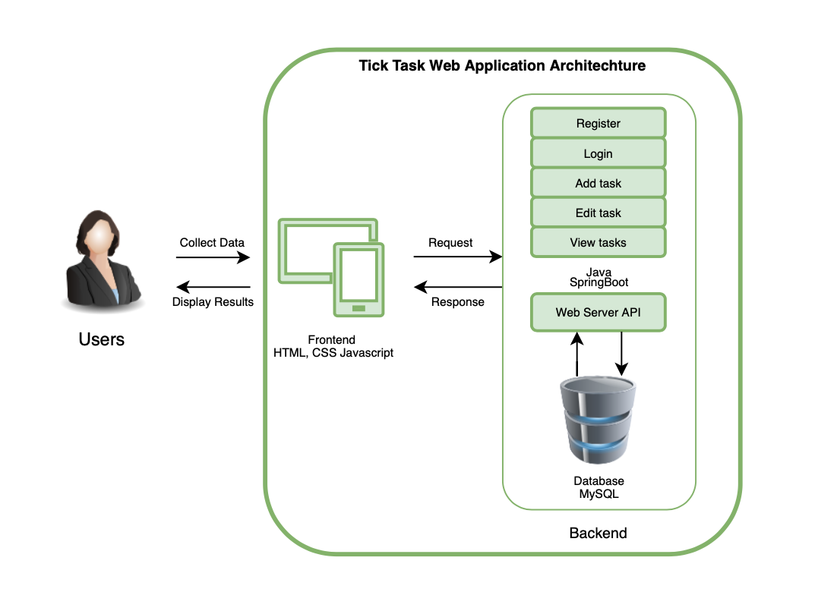

*Figure 3.1.1 Tick Task Web application Architecture View*

## **3.2 Hardware architecture**

The hardware required is a device connected with a high-speed internet on both the developers and user’s side.

## **3.3 Software architecture**

Softwares that have been used to implement this web application listed as follow

Java - An object-oriented programming language

Spring Boot - A Java based framework to help build web applications. It will also be used for testing and connecting the server to a database

MySQL - A database management system to manage all data for the software

Eclipse IDE - To build and develop java codes for the software

## **3.4 Performance**

Depending on the user's internet speed and device used, the response time shall take no longer than 2-5 seconds. To evaluate the software’s performance, a series of testing will be conducted to measure the stability and responsiveness. To ensure that the software is responding to meet the users need, these tests will be carried out by calculating concurrency rate, testing the server response time by a HTTP GET request from the end user’s browser and rendering response time by including tests scripts. (Wikipedia, 2022)

# 4. System Design

* + **Use cases**

Use cases for this project has been designed and demonstrated in the Requirements Specification document

* + **Database design**

The database of the web application is connected between the Tick Task database in MySQL and the Spring Boot as below Figure 4.1. Two tables have been created to store the data of the web application.

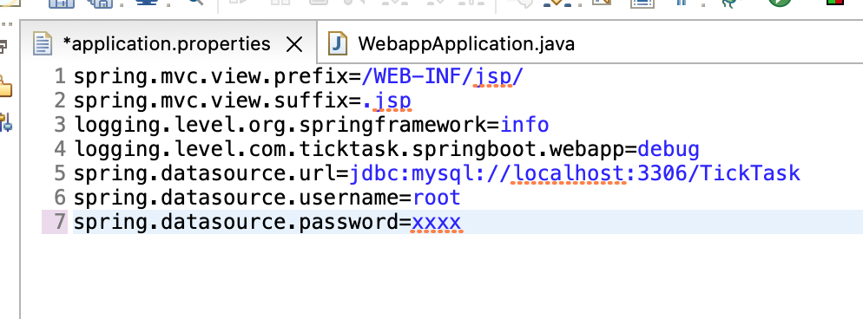

*Figure 4.1 MySQL database connected with Spring Boot*

From Figure 4.2, one table “Users” has been created to store users’ data and another table “Task” is used to store tasks data. All types of data have been gathered and organised. A few rows of data have been added to test and analyse for any errors that may happen. (Microsoft, 2021)

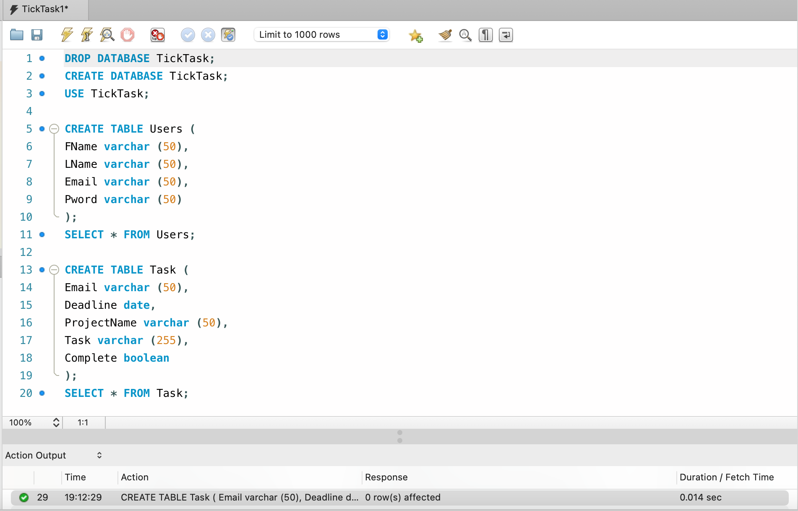

*Figure 4.2 MySQL Tick Task database*

The Spring Boot application used Hibernate and Spring data JPA connected to MySQL database as below Figure 4.3Hibernate ORM is an object–relational mapping tool to a relational database MySQL.

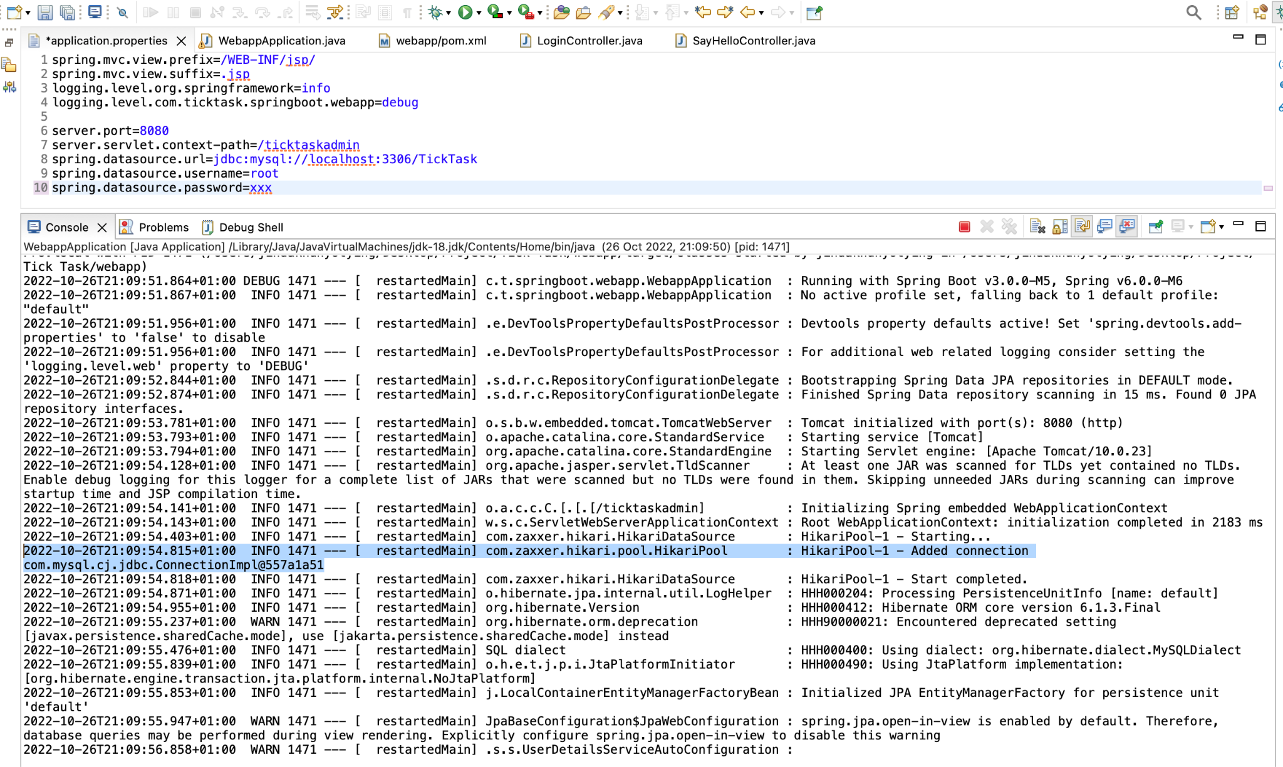*Figure 4.3 Spring Boot connected to MySQL using Hibernate*

* + **API description**

Currently this web application is not connected to the API. Once the web application has implemented more functionalities it is to be connected and synced with the user’s email and calendar.

# 5. Acronyms

API - Application Program Interface enables two applications to communicate with each other

HTTP - The Hypertext Transfer Protocol

GET - GET request retrieves data from a source on the internet

JDK - A Java Development Kit helps developers develop software with java programming language

IDE - A software application that develops use to code and build software

HTML - A markup language used to build websites

CSS - Style sheet language used to add styles to the web documents

# 6. References

Wikpedia., 2022. *Wikipedia.* [Online]   
Available at: https://en.wikipedia.org/wiki/Software_performance_testing  
[Accessed 10 2022].

Microsoft, 2021. *Microsoft.* [Online]   
Available at: https://support.microsoft.com/en-us/office/database-design-basics-eb2159cf-1e30-401a-8084-bd4f9c9ca1f5  
[Accessed 2022].